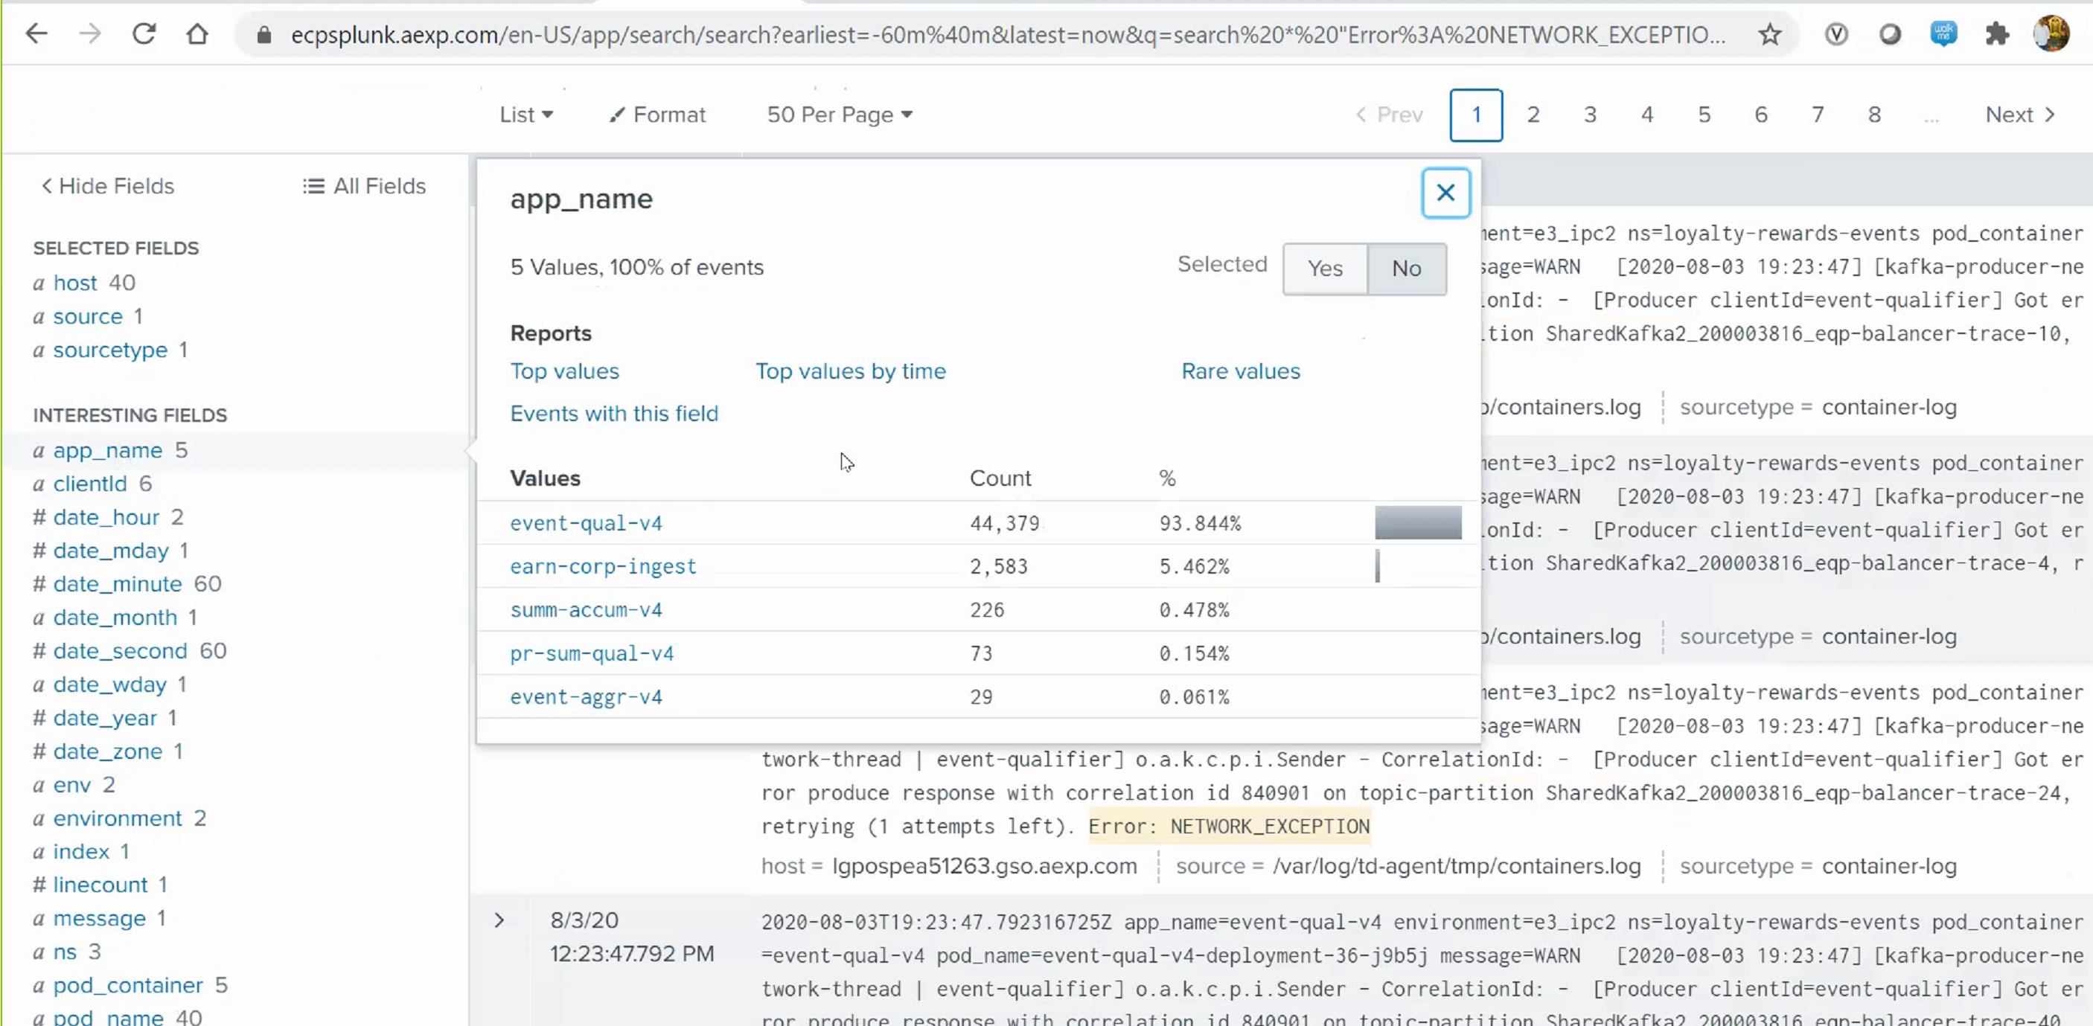

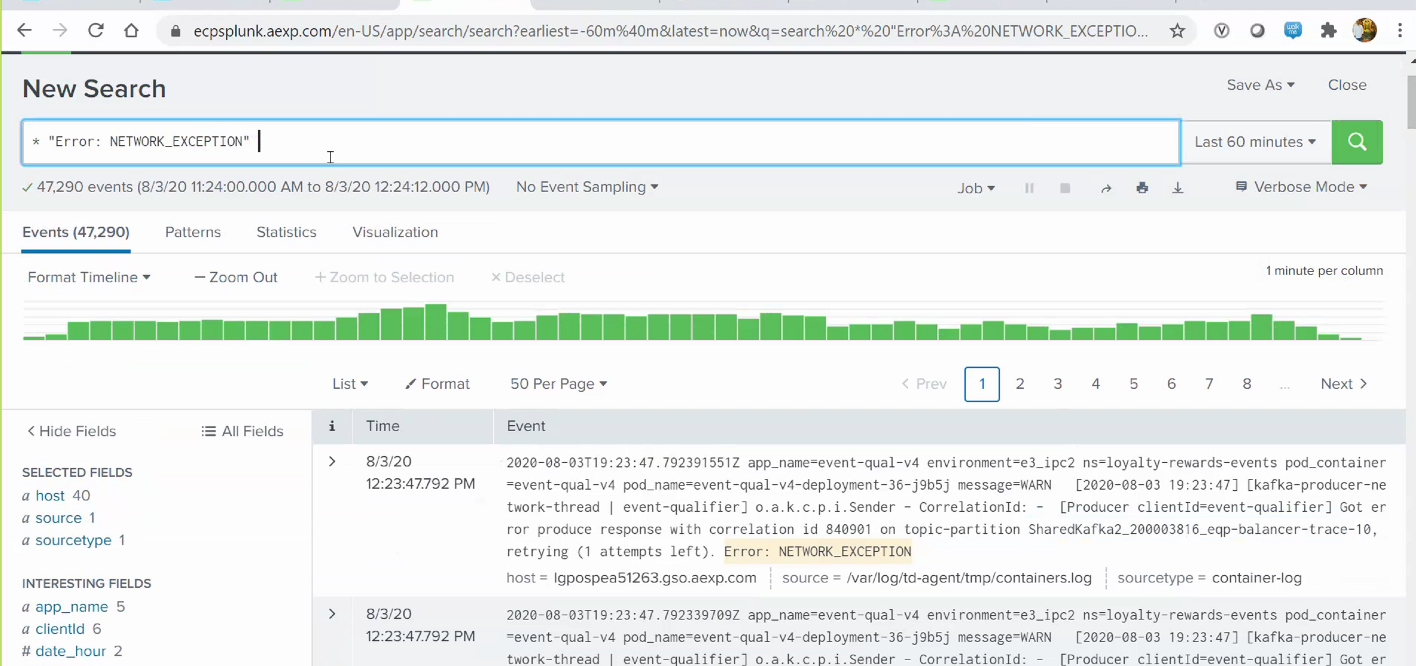

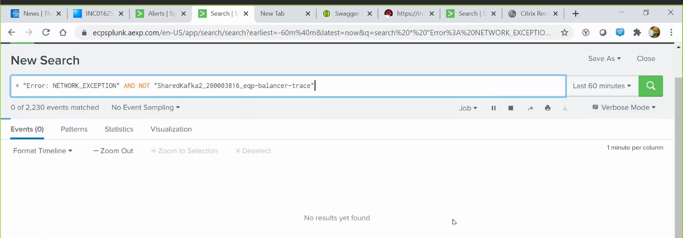

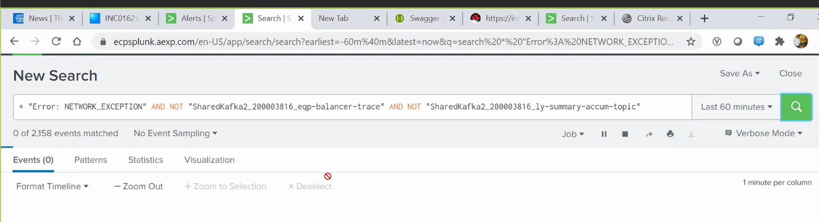

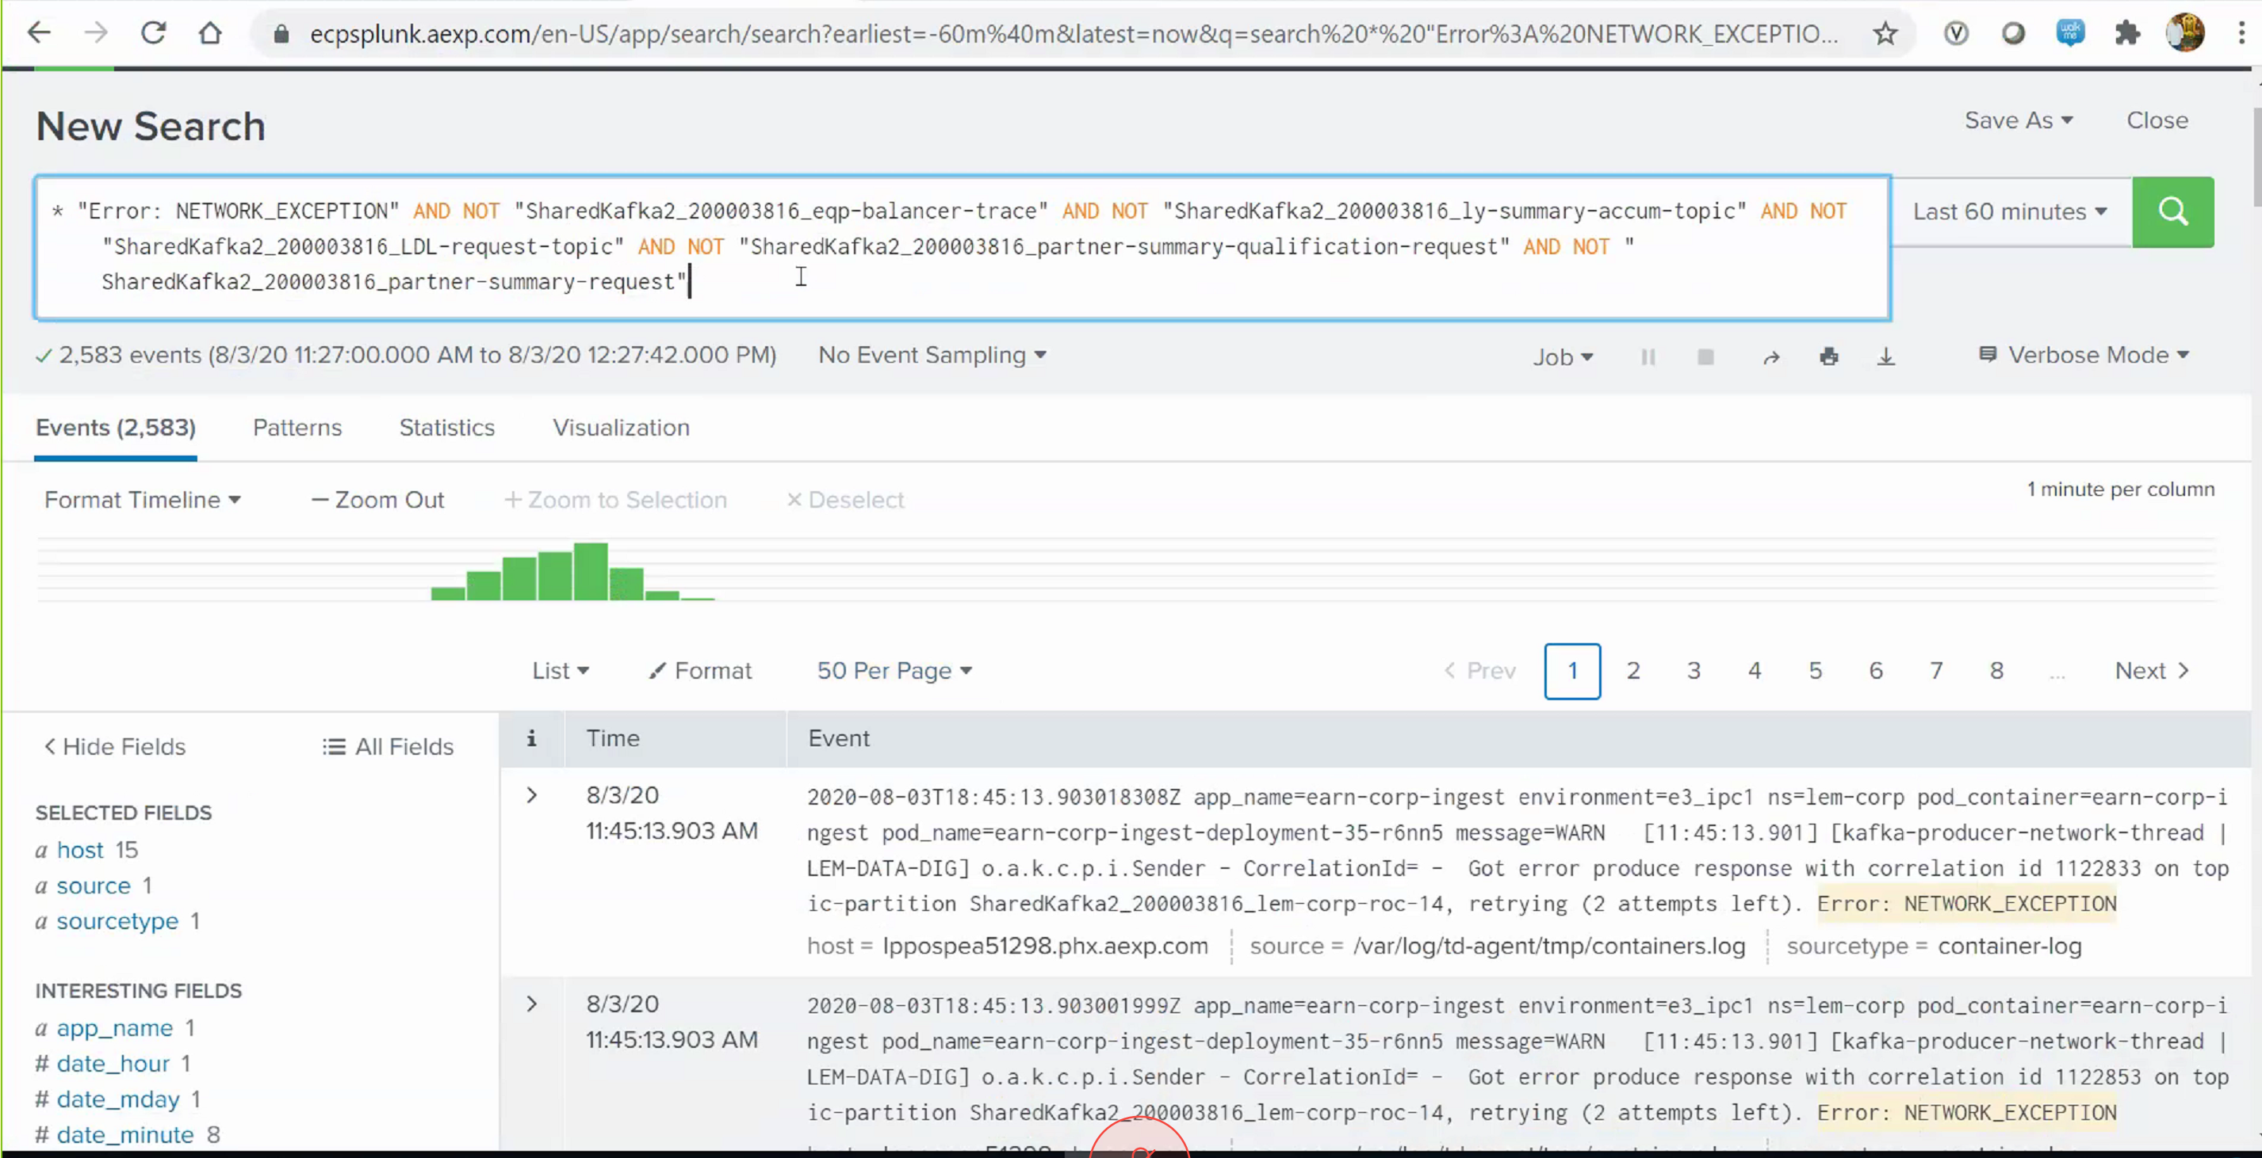

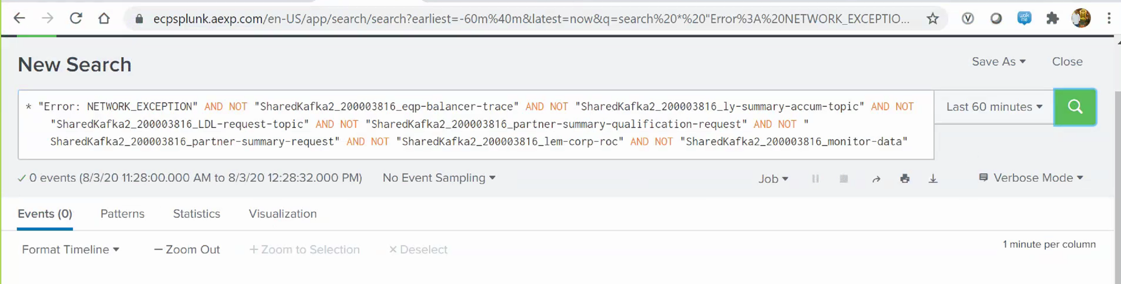

Could you please check the below KAFKA Topics.  
  
SharedKafka2_200003816_eqp-balancer-trace  
SharedKafka2_200003816_ly-summary-accum-topic  
SharedKafka2_200003816_LDL-request-topic  
SharedKafka2_200003816_partner-summary-qualification-request  
SharedKafka2_200003816_partner-summary-request  
SharedKafka2_200003816_lem-corp-roc  
SharedKafka2_200003816_monitor-data